Spanish 250th (Blue) Division takes on 2nd Shock Army, 1942

Introductions
This set of games is to introduce novice players to Crossfire and/or give more experienced players something to do until the main participation game starts.

Tables Sets
All six tables are 2’x2’. Only two of the tables are used at any one time. They come in pairs (1+2, 3+4, 5+6). Start with pair 1+2. Change the table pair when you run out of brochures for a particular set.

Morale
Morale depends on relative experience of the two players.

Balanced:
- Both Regular

Slight Difference:
- Stronger is Regular Defender;
- Weaker is Veteran Attacker

Significant Difference:
- Stronger is Green Defender
- Weaker is Veteran Attacker

Results
Record the results of each game: table, player, email, Soviet/Spanish, morale, result.

Email all participants with the results.

2
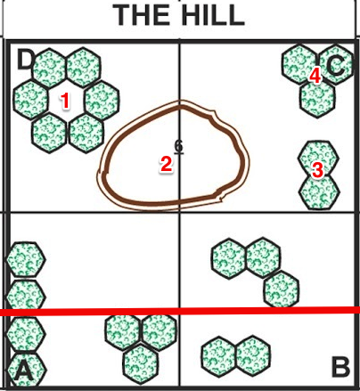

1
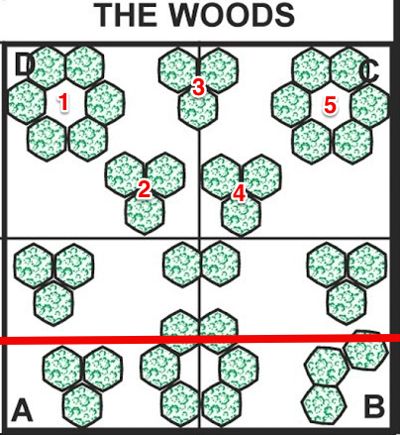
4
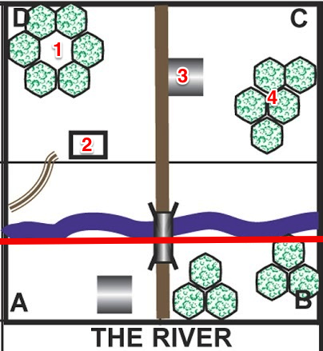

3
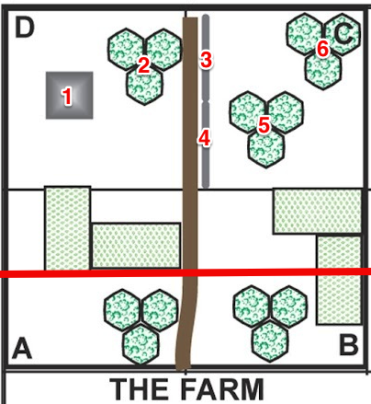

6
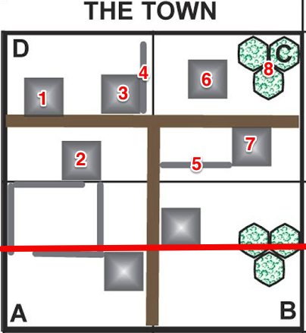

5
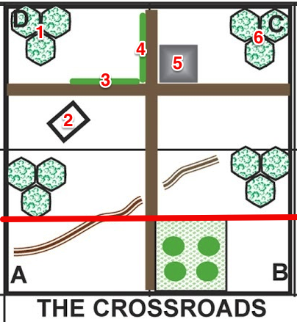

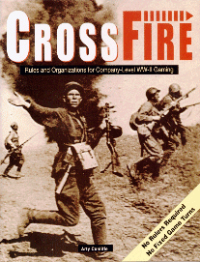
Company level wargaming for World War II by Arty Conliffe.

- No rulers
- No fixed game turns
- Emphasis on infantry
- Simple rules
- Subtle tactics

Low level WW2 combat at its most thrilling.
Finchley Wargaming Club
Historical Miniatures Gaming
All periods

Meets Sunday afternoon and some evenings at a private home in Finchley Central, N3, London

Contact
Steven Thomas
steven@balagan.org.uk

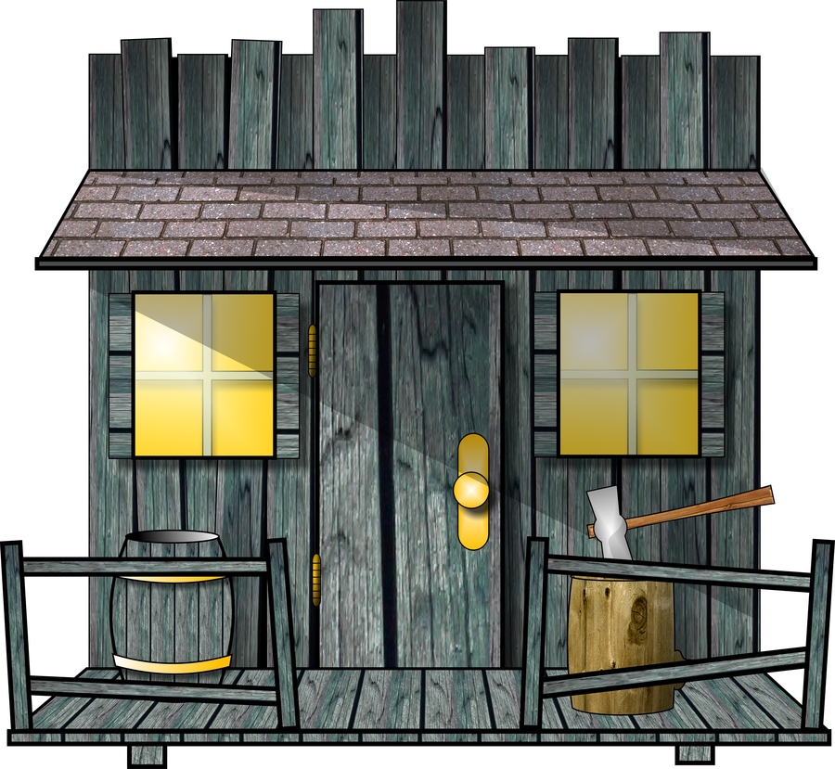

Spanish 250th (Blue) Division takes on 2nd Shock Army, 1942
On 31 May 1942 the Germans closed the Volkov pocket trapping the Soviet 2nd Shock under General Vlasov.
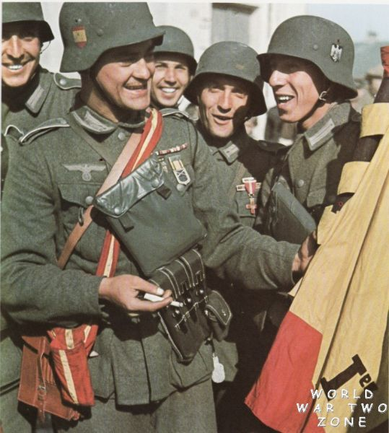
From 21 to 25 June 1942 a battle group under the German Colonel Burke attacked through thickly wooded and marshy terrain into the southern flank of the pocket.
The Spaniards of III/262 Battalion and 250 Reconnaissance Group, 250th (Blue) Division, led the way, making their German and Flemish companions look rather unenthusiastic.
At midday on 25 June the Spaniards put in the final, and successful, assault on Maloye Samoshie.

Victory Conditions:
Inflict casualties on the enemy. The side that loses 4 stands first loses.

Terrain
Woods. Lots of them.

Soviet Player (Defending)
The Soviets have a reinforced platoon:
Stand/Fortification |  |  |  |  |  |  |  | Hidden
PC (+1) |  |  |  |  |  |  |  | 1
Rifle Squad |  |  |  |  |  |  |  | 3
Rifle Squad |  |  |  |  |  |  |  | 3
Rifle Squad |  |  |  |  |  |  |  | 1
HMG |  |  |  |  |  |  |  | 1
On-table 50mm Mortar |  |  |  |  |  |  |  | 3
 |  |  |  |  |  |  |  |  | S | S | S | S
FO for off-table 82mm Mortar |  |  |  |  |  |  |  | 1
 |  |  |  |  |  |  |  |  | S | S | S | S
Sniper |  |  |  |  |  |  |  | 4
Minefield |  |  |  |  |  |  |  | 5
Deploys first, hidden in squares D and C. Secretly record location in table above and/or on map.

Based on Dick Bryant’s Crossfire Small 2’x2’ Scenarios

Spanish Player (Attacking)
The Spanish have two reinforced platoons:
Stand
PC (+1)
Rifle Squad
Rifle Squad
Rifle Squad
PC (+1)
Rifle Squad
Rifle Squad
Rifle Squad
HMG
Engineer Squad
On-table 5cm Mortar
 |  |  |  |  |  |  |  |  | S | S | S | S
FO for off-table 7.5cm Infantry Gun
 |  |  |  |  |  |  |  |  | S | S | S | S
Deploys visible in the “bottom” or southern 6” of squares A and B.
Deploys second and takes first initiative.
Company level wargaming for World War II by Arty Conliffe.

- No rulers
- No fixed game turns
- Emphasis on infantry
- Simple rules
- Subtle tactics

Low level WW2 combat at its most thrilling.
Finchley Wargaming Club
Historical Miniatures Gaming
All periods

Meets Sunday afternoon and some evenings at a private home in Finchley Central, N3, London

Contact
Steven Thomas
steven@balagan.org.uk

Spanish 250th (Blue) Division takes on 2nd Shock Army, 1942
On 31 May 1942 the Germans closed the Volkov pocket trapping the Soviet 2nd Shock under General Vlasov.
From 21 to 25 June 1942 a battle group under the German Colonel Burke attacked through thickly wooded and marshy terrain into the southern flank of the pocket.
The Spaniards of III/262 Battalion and 250 Reconnaissance Group, 250th (Blue) Division, led the way, making their German and Flemish companions look rather unenthusiastic.
At midday on 25 June the Spaniards put in the final, and successful, assault on Maloye Samoshie.

Victory Conditions:
Attacker occupies the hill (2) and holds for two complete initiatives.

Terrain
A hill and woods. Lots of them.

Soviet Player (Defending)
The Soviets have a reinforced platoon:
Stand/Fortification |  |  |  |  |  |  |  | Hidden
PC (+1)
Rifle Squad
Rifle Squad
Rifle Squad
HMG
On-table 50mm Mortar
 |  |  |  |  |  |  |  |  | S | S | S | S
FO for off-table 82mm Mortar
 |  |  |  |  |  |  |  |  | S | S | S | S
Sniper
Minefield
Deploys first, hidden in squares D and C. Secretly record location in table above and/or on map.

Based on Dick Bryant’s Crossfire Small 2’x2’ Scenarios

Spanish Player (Attacking)
The Spanish have two reinforced platoons:
Stand
PC (+1)
Rifle Squad
Rifle Squad
Rifle Squad
PC (+1)
Rifle Squad
Rifle Squad
Rifle Squad
HMG
Engineer Squad
On-table 5cm Mortar
 |  |  |  |  |  |  |  |  | S | S | S | S
FO for off-table 7.5cm Infantry Gun
 |  |  |  |  |  |  |  |  | S | S | S | S
Deploys visible in the “bottom” or southern 6” of squares A and B.
Deploys second and takes first initiative.
Company level wargaming for World War II by Arty Conliffe.

- No rulers
- No fixed game turns
- Emphasis on infantry
- Simple rules
- Subtle tactics

Low level WW2 combat at its most thrilling.
Finchley Wargaming Club
Historical Miniatures Gaming
All periods

Meets Sunday afternoon and some evenings at a private home in Finchley Central, N3, London

Contact
Steven Thomas
steven@balagan.org.uk

Spanish 250th (Blue) Division takes on 2nd Shock Army, 1942
On 31 May 1942 the Germans closed the Volkov pocket trapping the Soviet 2nd Shock under General Vlasov.
From 21 to 25 June 1942 a battle group under the German Colonel Burke attacked through thickly wooded and marshy terrain into the southern flank of the pocket.
The Spaniards of III/262 Battalion and 250 Reconnaissance Group, 250th (Blue) Division, led the way, making their German and Flemish companions look rather unenthusiastic.
At midday on 25 June the Spaniards put in the final, and successful, assault on Maloye Samoshie.

Victory Conditions:
Attacker occupies the farm house (1) and holds for two complete initiatives.

Terrain
Farm house (1), fields, walls (3,4) and woods.
Fields are “In Season”. Buildings hold 2 stands excluding PCs and FOs.

Soviet Player (Defending)
The Soviets have a reinforced platoon:
Stand/Fortification |  |  |  |  |  |  |  | Hidden
PC (+1)
Rifle Squad
Rifle Squad
Rifle Squad
HMG
On-table 50mm Mortar
 |  |  |  |  |  |  |  |  | S | S | S | S
FO for off-table 82mm Mortar
 |  |  |  |  |  |  |  |  | S | S | S | S
Sniper
Minefield
Deploys first, hidden in squares D and C. Secretly record location in table above and/or on map.

Based on Dick Bryant’s Crossfire Small 2’x2’ Scenarios

Spanish Player (Attacking)
The Spanish have two reinforced platoons:
Stand
PC (+1)
Rifle Squad
Rifle Squad
Rifle Squad
PC (+1)
Rifle Squad
Rifle Squad
Rifle Squad
HMG
Engineer Squad
On-table 5cm Mortar
 |  |  |  |  |  |  |  |  | S | S | S | S
FO for off-table 7.5cm Infantry Gun
 |  |  |  |  |  |  |  |  | S | S | S | S
Deploys visible in the “bottom” or southern 6” of squares A and B.
Deploys second and takes first initiative.
Company level wargaming for World War II by Arty Conliffe.

- No rulers
- No fixed game turns
- Emphasis on infantry
- Simple rules
- Subtle tactics

Low level WW2 combat at its most thrilling.
Finchley Wargaming Club
Historical Miniatures Gaming
All periods

Meets Sunday afternoon and some evenings at a private home in Finchley Central, N3, London

Contact
Steven Thomas
steven@balagan.org.uk

Spanish 250th (Blue) Division takes on 2nd Shock Army, 1942
On 31 May 1942 the Germans closed the Volkov pocket trapping the Soviet 2nd Shock under General Vlasov.
From 21 to 25 June 1942 a battle group under the German Colonel Burke attacked through thickly wooded and marshy terrain into the southern flank of the pocket.
The Spaniards of III/262 Battalion and 250 Reconnaissance Group, 250th (Blue) Division, led the way, making their German and Flemish companions look rather unenthusiastic.
At midday on 25 June the Spaniards put in the final, and successful, assault on Maloye Samoshie.

Victory Conditions:
Attacker gets the majority of his force into the building (3) and right-hand woods (4). Then hold for two complete initiatives.

Terrain
Buildings (inc. 3), bunker (2), crest, river, roads, bridge and woods.
The river is a “linear obstacle”, but fordable. Buildings/Bunkers hold 2 stands excluding PCs and FOs.

Soviet Player (Defending)
The Soviets have a reinforced platoon:
Stand/Fortification |  |  |  |  |  |  |  | Hidden
PC (+1)
Rifle Squad
Rifle Squad
Rifle Squad
HMG
On-table 50mm Mortar
 |  |  |  |  |  |  |  |  | S | S | S | S
FO for off-table 82mm Mortar
 |  |  |  |  |  |  |  |  | S | S | S | S
Sniper
Minefield
Deploys first, hidden in squares D and C. Secretly record location in table above and/or on map.

Based on Dick Bryant’s Crossfire Small 2’x2’ Scenarios

Spanish Player (Attacking)
The Spanish have two reinforced platoons:
Stand
PC (+1)
Rifle Squad
Rifle Squad
Rifle Squad
PC (+1)
Rifle Squad
Rifle Squad
Rifle Squad
HMG
Engineer Squad
On-table 5cm Mortar
 |  |  |  |  |  |  |  |  | S | S | S | S
FO for off-table 7.5cm Infantry Gun
 |  |  |  |  |  |  |  |  | S | S | S | S
Deploys visible in the “bottom” or southern 6” of squares A and B.
Deploys second and takes first initiative.
Company level wargaming for World War II by Arty Conliffe.

- No rulers
- No fixed game turns
- Emphasis on infantry
- Simple rules
- Subtle tactics

Low level WW2 combat at its most thrilling.
Finchley Wargaming Club
Historical Miniatures Gaming
All periods

Meets Sunday afternoon and some evenings at a private home in Finchley Central, N3, London

Contact
Steven Thomas
steven@balagan.org.uk

Spanish 250th (Blue) Division takes on 2nd Shock Army, 1942
On 31 May 1942 the Germans closed the Volkov pocket trapping the Soviet 2nd Shock under General Vlasov.
From 21 to 25 June 1942 a battle group under the German Colonel Burke attacked through thickly wooded and marshy terrain into the southern flank of the pocket.
The Spaniards of III/262 Battalion and 250 Reconnaissance Group, 250th (Blue) Division, led the way, making their German and Flemish companions look rather unenthusiastic.
At midday on 25 June the Spaniards put in the final, and successful, assault on Maloye Samoshie.

Victory Conditions:
Attacker must occupy house (5) and hedge area (3,4) and holds for two complete initiatives.

Terrain
Building (5), bunker (2), hedges (3,4), crests, roads, orchard and woods.
Orchard is “in season”. Buildings/Bunkers hold 2 stands excluding PCs and FOs.

Soviet Player (Defending)
The Soviets have a reinforced platoon:
Stand/Fortification |  |  |  |  |  |  |  | Hidden
PC (+1)
Rifle Squad
Rifle Squad
Rifle Squad
HMG
On-table 50mm Mortar
 |  |  |  |  |  |  |  |  | S | S | S | S
FO for off-table 82mm Mortar
 |  |  |  |  |  |  |  |  | S | S | S | S
Sniper
Minefield
Deploys first, hidden in squares D and C. Secretly record location in table above and/or on map.

Based on Dick Bryant’s Crossfire Small 2’x2’ Scenarios

Spanish Player (Attacking)
The Spanish have two reinforced platoons:
Stand
PC (+1)
Rifle Squad
Rifle Squad
Rifle Squad
PC (+1)
Rifle Squad
Rifle Squad
Rifle Squad
HMG
Engineer Squad
On-table 5cm Mortar
 |  |  |  |  |  |  |  |  | S | S | S | S
FO for off-table 7.5cm Infantry Gun
 |  |  |  |  |  |  |  |  | S | S | S | S
Deploys visible in the “bottom” or southern 6” of squares A and B.
Deploys second and takes first initiative.
Company level wargaming for World War II by Arty Conliffe.

- No rulers
- No fixed game turns
- Emphasis on infantry
- Simple rules
- Subtle tactics

Low level WW2 combat at its most thrilling.
Finchley Wargaming Club
Historical Miniatures Gaming
All periods

Meets Sunday afternoon and some evenings at a private home in Finchley Central, N3, London

Contact
Steven Thomas
steven@balagan.org.uk

Spanish 250th (Blue) Division takes on 2nd Shock Army, 1942
On 31 May 1942 the Germans closed the Volkov pocket trapping the Soviet 2nd Shock under General Vlasov.
From 21 to 25 June 1942 a battle group under the German Colonel Burke attacked through thickly wooded and marshy terrain into the southern flank of the pocket.
The Spaniards of III/262 Battalion and 250 Reconnaissance Group, 250th (Blue) Division, led the way, making their German and Flemish companions look rather unenthusiastic.
At midday on 25 June the Spaniards put in the final, and successful, assault on Maloye Samoshie.

Victory Conditions:
Attacker clears or occupies 3 of the buildings in D and C and holds for two complete initiatives.

Terrain
Buildings, walls, roads and woods.
Buildings hold 2 stands excluding PCs and FOs.

Soviet Player (Defending)
The Soviets have a reinforced platoon:
Stand/Fortification |  |  |  |  |  |  |  | Hidden
PC (+1)
Rifle Squad
Rifle Squad
Rifle Squad
HMG
On-table 50mm Mortar
 |  |  |  |  |  |  |  |  | S | S | S | S
FO for off-table 82mm Mortar
 |  |  |  |  |  |  |  |  | S | S | S | S
Sniper
Minefield
Deploys first, hidden in squares D and C. Secretly record location in table above and/or on map.

Based on Dick Bryant’s Crossfire Small 2’x2’ Scenarios

Spanish Player (Attacking)
The Spanish have two reinforced platoons:
Stand
PC (+1)
Rifle Squad
Rifle Squad
Rifle Squad
PC (+1)
Rifle Squad
Rifle Squad
Rifle Squad
HMG
Engineer Squad
On-table 5cm Mortar
 |  |  |  |  |  |  |  |  | S | S | S | S
FO for off-table 7.5cm Infantry Gun
 |  |  |  |  |  |  |  |  | S | S | S | S
Deploys visible in the “bottom” or southern 6” of squares A and B.
Deploys second and takes first initiative.

